Assignment 1 :- Performed on Azure By Lavin Choudhary.

Q1:- Create a file, assign permissions (read, write, execute) to different user categories (owner, group, others), and practice changing permissions using chmod.

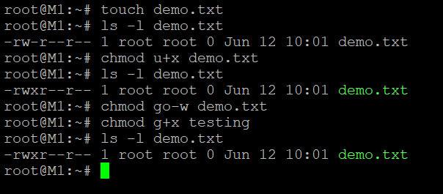

Q2 :- Execute basic Linux commands (e.g., ls, cd, mkdir, rm, touch) to manipulate files and directories, with an emphasis on understanding their usage.

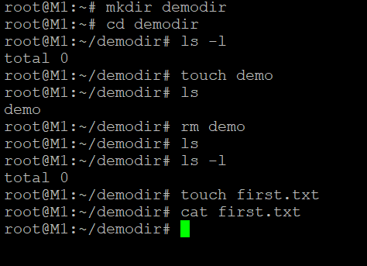

Q3 :- Using the terminal, practice navigating through directories, listing file contents, and moving files to different locations.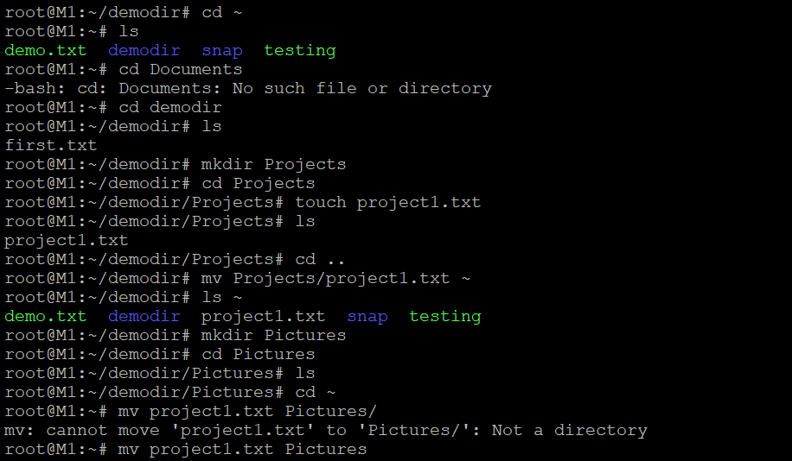

Q4 :- Create a new user and group, set their permissions, and explore user management commands like useradd, usermod, and userdel.

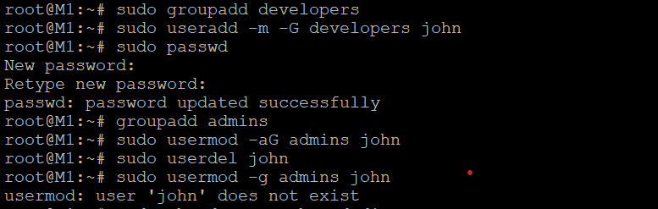

Q5:- Practices more linux commands.

We can practice many command like grep, find , chown , tail etc.